School Context as at 24th April 2023

School Roll School attendance Percentage ASN PEF allocation

…
£155,520

SIMD profile

Cycle of Improvement Our Aims and Values
Based on Summary Self-evaluation, School Improvement Report,
Annual Audit and feedback from Key Partners
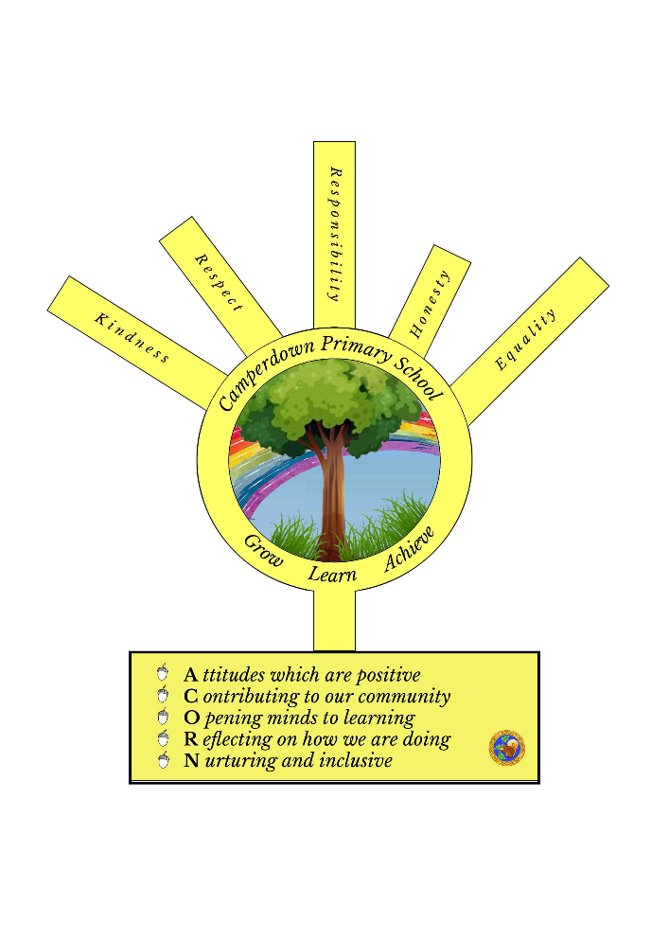

SIP Priority 1  Specific area for improvement  PEF Equity Gap (if relevant) | Getting it Right at Camperdown PS – a focus on learning and teaching.  Promoting a high quality learning experience.
NIF PRIORITY  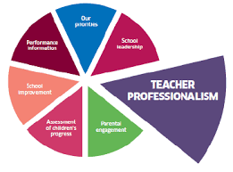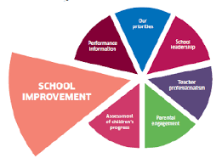 |  | EDLM PRIORITY  Progress | PEF (where applicable)  Intervention for equity & cost  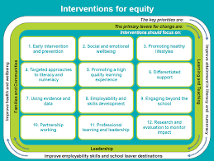  5.Promoting a high-quality learning experience.  £50,000 | HGIOS QI  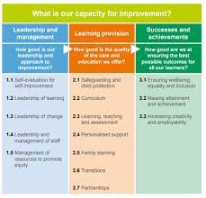  2.3 | 3.2
Action |  | Outcomes and Measurement Including use of HGIOS Challenge questions | Responsibility | Timescale | Progress
All teachers engaging in learning trios to focus on high quality learning and teaching episodes across all levels to ensure pupil participation.  SLT to use coaching model to support and challenge.  All staff engaging with research and using CAR methodologies and data from their individual class.  Fortnightly stand ups with SLT to monitor progress and impact within the classroom.  PEF teacher to be used to target specific children in P2 and P5 in the first instance to support closing the gap. Working on a 6 week cycle. |  | Observations from PSVs in 2022/23 showed learning and teaching was inconsistent across the school. Learning and Teaching Standard was not implemented.  Our aim is to have an agreed learning and teaching standard in our school which allows pupils to be leaders of their learning. This should then impact on pupil progress and achievement.  Pupil attainment at P1, P4 and P7 to be consistently at 80% or above in all areas.  All teachers to use clarifying canvas models and fortnightly stand ups to show individual class progress and impact.  How well do we motivate and engage all learners in all aspects of school life?  How well are our approaches to raising attainment improving outcomes for children and young people? | Teaching Trios with identified SLT member to check in with. This project will run over the whole school year.  - Aug-Dec – Improving pupil engagement. Measured pre and post using Leuven’s scale.  - Jan-March – Improving planning and assessment practices.  - April-June – Developing leaders of learning. | This box should be used to note progress throughout the session

SIP Priority 2  Specific area for improvement  PEF Equity Gap (if relevant) | Pupil Leadership – a focus within the classroom and beyond (PARTICPATION)  8. Employability and skills development
NIF PRIORITY  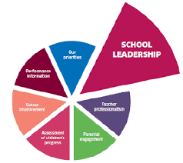 |  | EDLM PRIORITY  Participation | PEF (where applicable)  Intervention for equity & cost  8. Employability and skills development | HGIOS QI  1.2 | 1.3
Action |  | Outcomes and Measurement Including use of HGIOS Challenge questions | Responsibility | Timescale | Progress
Increase and develop the leadership opportunities for pupils in the school.  - Eco committee  - Playground buddies  - School captains  - Digi Leaders  - UNCRC  - Junior Librarians  - Learning council  - Sports Leaders  Implement Digital Schools Action Plan.  Implement Rights Respecting Schools Action Plan.  Implement Eco Schools Plan.  Provide training opportunities and regular meetings for all leadership roles. |  | - There is inconsistent pupil voice evident in summary self- evaluation. Audit against standards for RRSA, Digi Schools and Eco School to identify direction of travel.  - Pre and post questionnaires to be given to all pupils to measure how pupil voice is valued at Camperdown.  - Learners will be resilient and confident and be able to make decisions and feel valued in the running of our school.  How effectively do we create a learning culture in our school?  To what extend to we support our children and young people to take responsibility for their own learning and progress?  Does everyone in our school have a clear understanding of our collective strengths and areas for development? | - Staff leaders of RRSA to support pupils in submitting evidence and action plan to achieve silver award by June 2024.  - Staff digital leaders to support pupils in gathering evidence to achieve the digital schools award by June 2024.  - Staff leaders of Eco schools to support pupils in submitting evidence and action plan to retain the Green Flag status by June 2024.  - Staff leaders to schedule regular meetings each term to support pupils.  - Active Schools Assistant to identify, train and support pupils to become sports leaders by Oct 2023.  - SLT to gather data from pre and post questionnaires on pupil voice in Aug 2023 and May 2024. | This box should be used to note progress throughout the session

SIP Priority 3  Specific area for improvement  PEF Equity Gap (if relevant) | Attendance – a focus on late coming and time lost in the classroom.  - Early intervention and prevention
NIF PRIORITY  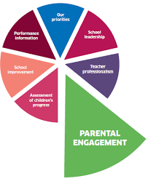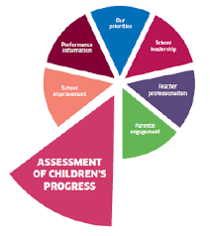 |  | EDLM PRIORITY  Presence | PEF (where applicable)  Intervention for equity & cost  - Early intervention and prevention. £2000 | HGIOS QI  3.1
Action |  | Outcomes and Measurement Including use of HGIOS Challenge questions | Responsibility | Timescale | Progress
SFDW to use data to identify the next cohort of children for late coming intervention. She will meet with parents and share the objectives of the late coming group.  Weekly breakfast sessions to be carried out with the late coming group. These will also focus on strategies for independence on coming to school.  School attendance procedures and guidance to be shared with parents in Aug.  Monthly ARG to continue to focus on attendance and late coming. |  | All pupils involved will have more time spent in the classroom due to improved time keeping. This will then impact on overall attendance.  PDSA model used to measure impact. Children are completing individual records of late coming weekly and this is shared with parents/carers.  How well do we ensure that all children feel safe, healthy, achieving, nurtured, active, respected, responsible and included? | SFDW 10 weeks for each cycle. | This box should be used to note progress throughout the session

