Dundee Primary School

School Improvement Report
Session 2022-23



Camperdown Primary School
Buttar’s Street,
Dundee. DD2 4PQ
Tel 436633
Email: ccamperdownprimary@dundeeschools.scot

This document shares and celebrates the improvements in our School and embraces all ages and stages. It is based upon our School Improvement Plan for session 2022-23

Camperdown Primary Vision, Values and Aims

Our Vision: Grow Learn Achieve

Our Values: Kindness Respect Honesty Responsibility Equality

Our Aims: Attitudes which are positive
Contributing to our community
Opening minds to learning
Reflecting on how we are doing
Nurturing and inclusive

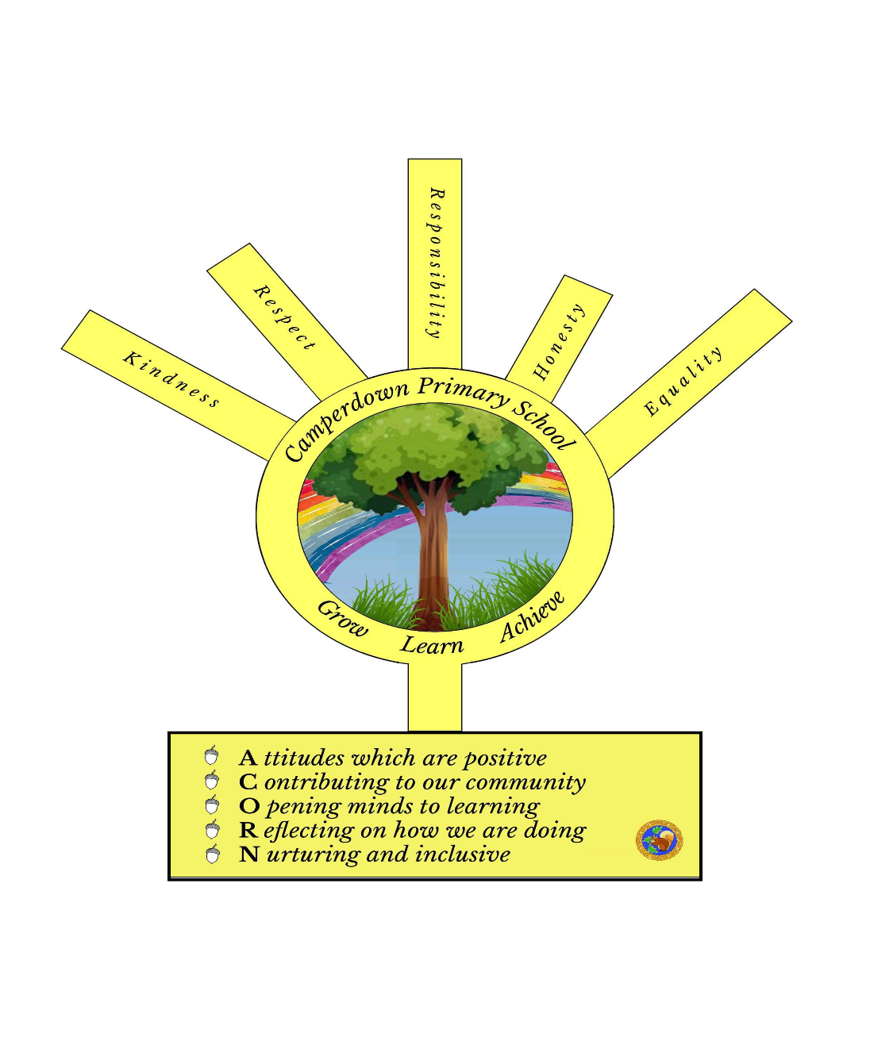

Context of the School:

Camperdown Primary School is a nondenominational school, whose catchment area consists of the Lochee and Charleston communities. The school is part of the shared campus at Buttars Street and shares the building with St Clement’s RC Primary School to form Balgarthno Campus.

We have a nursery class with 74 full time places. The current school roll is 232 with 71.1% of our current school population living in SIMD 1 and 2.

We strive to provide equity for all learners, raising attainment across all levels remains a key focus of all improvement work within the school. We continue to work and support families in order for them to support their child’s learning. Our SFDW continues to work closely with families to provide the support needed.

We offer a wide range of experiences across the curriculum to ensure all learners become confident individuals, successful learners, effective contributors and responsible citizens. We work closely with partners to provide a variety of learning experiences e.g. Active Schools, ASPIRE music tutors, Camperdown Church, Camperdown Park Rangers, Accessibilities and Inclusion Team, Charleston Library and DEPS so that children can develop skills for life, learning and work.

Attainment Data 2022-23
(percentages)
 | Reading | Writing | Talking and Listening | Numeracy
Primary 1  (CFE Early Level) | 75% | 80% | 90% | 85%
Primary 4  (CFE 1st Level) | 71% | 60% | 80% | 66%
Primary 7  (CFE 2nd Level) | 89% | 83% | 96% | 74%

Review of Improvement Progress for Session 2022-23

School Improvement Priority 1: Improving Pedagogy

Progress and Impact:

- Enquiry set up with teaching staff who focused on effective use of questioning for children to lead their learning and increased pupil engagement. Staff engaged with the Teaching Cycle and applied a variety of strategies across a number of classes. Observations show an increased participation and pupils motivated by Assessment is for Learning (AiFL) strategies.
- Listening and Talking attainment is our strongest area across the school.
- All Camperdown Staff involved in working with the Pedagogy Team to evaluate our curriculum offer. Effective discussions about what is unique to Camperdown PS, this work will continue next session.
- All teaching staff attended a CLPL offer led by the HT on assessment. This was a chance to revisit and think about the planning of assessment activities. All learners now have an assessment profile for Reading, Writing and Listening and Talking. Assessment checklists are linked to the progression pathways, so this has allowed greater discussions and evidence gathering to support achievement of a level.
- All staff have complete Trauma Informed Training levels 1 and 2. We have created a School Action Plan which sits beside our Positive Relationship Policy. All staff are understanding of the possible impacts of trauma for our learners.
- Playroom was set up and used well within the Infant Department. This has allowed us to provide play-based learning opportunities. Enquiry Group focused on the use of observations to ensure learning is captured and built upon. Group feedback to all teaching staff and observation sheet can be used across all stages.
- P5 and P5/6 worked with Scrap Antics using Loose Parts Play. Targeted groups for resilience and observations of play show improvements for these targeted pupils.
- All teaching staff meet with SLT 3 times per year to track pupil progress. Interventions are fluid and additional teacher has been used to target groups every 6-8 weeks. Monitoring of interventions show all learners are making progress at their own level.

Next Steps:

- Learning and Teaching to remain a focus on next session’s School Improvement Plan. This will allow all practitioners to engage in professional learning about high quality interactions across all levels. Staff will work in learning trios. This will focus on effect8ive questioning and pupil voice.
- Continue to engage with the Pedagogy Team to revisit our curriculum offer. We will engage with pupils and parents to highlight the priorities and agree a final design.
- Assessment profiles to continue and to look at developing this for Numeracy.
- Continue to develop the use of play across the school. Observations to be used as part of evidence of achievement of a level and to inform next steps in learning.
- Continue partnership with Scrap Antics and the use of Loose Parts over break times.
- As part of our Learning and Teaching focus, we will look at the learning environment and ensure we are creating safe spaces for our learners, this will be part of our universal provision and all staff to reference the DCC’s Good Practice Checklist.

School Improvement Priority 2: Improve Feedback for All Learners

Progress and Impact:

- All teaching staff have attended 3 sessions with the Pedagogy Team to focus on meta skills and how these can be used with the pupils to reflect on their learning. All staff have a good understanding of the skills and how these can be shared with the pupils. All meta skills have been introduced with the pupils through Assembly, this has allowed the pupils to begin to use this language.
- All learners are using Seesaw and are reflecting on termly goals. We have devised a Seesaw Policy and have reviewed this twice over the session. Learners from P3/4-P7 were able to talk about their Seesaw with SLT during Pupil Forum discussions.
- Learning Council in place and they reviewed the School Improvement Plan. The pupils can articulate the priorities and have created a wall display to show these.
- Digi-Leaders are in place, pupils applied for this position. We have 12 senior pupils who have taken on this role. The children have clear remits and carry out their duties, supporting other classes and supporting the use of laptops across the school.
- We have supported our ICT Co-ordinator with time out of class each week. This has allowed for some team teaching and modelling to support staff confidence. ICT Co-ordinator issued a questionnaire to staff to gauge what support was required. Drop-in support on offer for all staff.
- Staff reviewed timetables to ensure time was given to feedback to pupils. Pupil Forum discussions showed that children receive feedback in a variety of ways, and they all knew why they received this feedback. Some staff using a rotation strategy to ensure they see all learners over the week. One member of staff went to visit one of our link schools to see Feedback Friday in action. This was viewed very positively and has been shared with colleagues.

Next Steps:

- Introduce consistent approach to sharing meta skills at the start of each lesson. Teachers to make this explicit so pupils can use language consistently in their reflections. Teachers to use progression frameworks so skills are highlighted and included in their planning.
- Continue to use Seesaw and monitor interactions. All pupils to continue to post and reflect on their learning.
- Pupil Council to continue to engage with Wee HGIOs and evaluate our school. Meetings to be more regular and ensure time is given back in class to share information.
- As part of the high-quality learning and teaching focus, all teachers to ensure they are giving feedback to all learners and we have a consistent approach to this. P1s to trial Feedback Friday.

School Improvement Priority 3: Embed Writing Pedagogy Across the Whole School.

Progress and Impact:
- Writing remained a focus for school for another year. This was a year to embed learning and new approaches. All staff are using the Year Plan for writing, this ensures coverage across all contexts and all text types. This is evident in learners’ written work a variety of genres have been taught and learners can discuss these.
- Cold and Hot pieces continue to be used for pre and post assessment. These are tracked closely with the progression frameworks so children can see the areas they need to improve on. All teachers are working with stage partners to moderate writing. Cluster event held in May Inset to look at achievement of a level across the whole cluster. Staff shared that this was useful to see what each level looks like.
- Whole School verification event held in May, this allowed professional discussions around achievement of a level and staff could see the progression in learning across the whole school.
- All classes introduced the Daily Write. This focused on the tools for writing. Pareto charts kept to see areas that required focus and targeted children were monitored through this. Our attainment levels are showing an improvement at P1 and P7 this session. Pupil Forum discussions shared that the pupils are becoming more confident with writing and know the Daily Write is there to help them improve.
- Enquiry Group focused on the use of ICT to support off track learners. The Group engaged with research and linked with the Pedagogy Team to try apps and software to support. Pre and post surveys were carried out with the learners and showed that they felt more confident using ICT to support their writing. Staff moderated pieces of work and it shows that pupils were meeting benchmarks for writing when supported with ICT.

Next Steps:

- The Daily Write and this approach to writing is to continue and become part of everyday learning and teaching at Camperdown PS.
- Pareto charts to be used to track focus on Daily Write and monitor the impact.
- ICT Co-ordinator to support staff with the use of ICT in their classes. Upscale the success of Enquiry Group and share across all levels to support targeted children.

Improvement Priorities for Session 2023-24

1. Getting it Right at Camperdown PS – a focus on learning and teaching (PROGRESS)

2. Pupil Leadership – a focus within the classroom and beyond (PARTICPATION)

3. Attendance – a focus on late coming and time lost in the classroom (PRESENCE)

Please submit this completed document by e mail to your link Education Officer.

Please visit www.careinspectorate.com or https://education.gov.scot/what-we-do/inspection-and-review/reports for Care Inspectorate or HMIE Inspection Reports.

https://parentzone.org.uk/

Further Information can be found at:

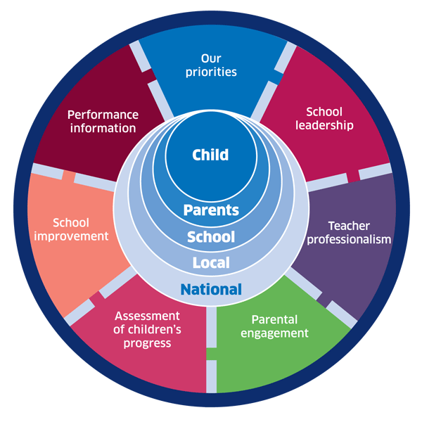 | 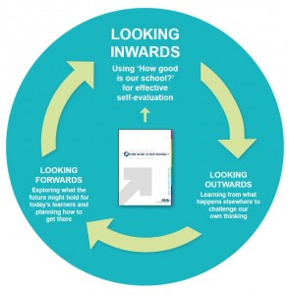 |  |   Dundee Education Plan  https://www.dundeecity.gov.uk/sites/default/files/publications/annual_education_plan_2017-18.pdf
National Improvement Framework  http://www.gov.scot/Publications/2016/01/8314 | HGIOS 4 Self-evaluation https://education.gov.scot/improvement/Documents/Frameworks_SelfEvaluation/FRWK2_NIHeditHGIOS/FRWK2_HGIOS4.pdf | Tayside Plan C&FS  External Link ' Tayside_Plan 1a.pdf'

