CAMPERDOWN PRIMARY SCHOOL

NURSERY CLASS



Parent Information Booklet

Welcome to our school! Camperdown Primary School is a nondenominational school, whose catchment area consists of the Lochee and Charleston communities. The school is part of the shared campus at Buttar’s Street and shares the building with St Clement’s RC Primary School to form Balgarthno Campus. We have a nursery roll of with 74 places. The current school roll is 276.

At Camperdown Primary School our vision is to allow every person within our community to chance to Grow, Learn and Achieve.

Our school values are implemented through creating a safe, welcoming, happy, positive and inclusive learning environment, which nurtures all who belong there and enables children to develop the four capacities of successful learners, confident individuals, responsible citizens and effective contributors.

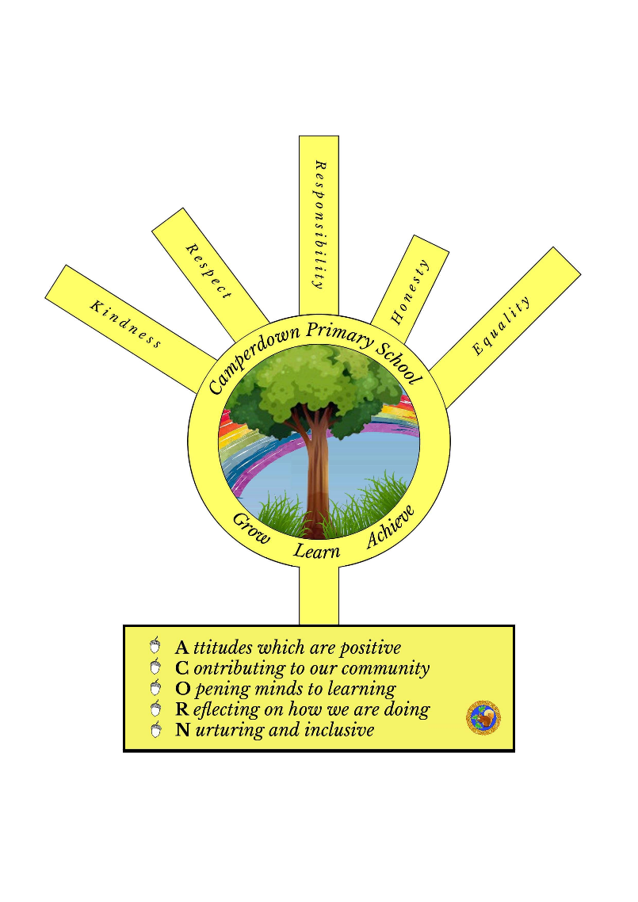
We endeavour to provide the highest possible standards of quality teaching and learning. We promote high expectations and positive relationships in partnership with parents and other partners in the community.

Yours sincerely

Mrs N Weryk
Head Teacher

The nursery aims to address the individuality of each child by offering a child-centred approach to learning. A wide range of experiences are provided both in the nursery and outside. The children are encouraged to make choices and are actively involved and encouraged to lead their learning.

In a challenging and creative environment and through a wide range of play activities, our curriculum promotes and develops the following aspects: independence and self-help skills, curiosity, creativity, social skills, and a genuine love of learning.

Nursery Enrolment
A notice in the local press in February will advise parents of future Nursery pupils when to enrol their child in Nursery. Parents should then contact the office to collect an enrolment form. The child’s birth certificate and a recent proof of address, (within the last 3 months) must be produced before registration can be completed.

Children generally begin Nursery at specific points in the year. One in August, January and April. If you require any further information about enrollment and registration please visit the Dundee City Council website.

Starting Nursery - Updated for COVID-19.
When your child starts nursery for the first time, we would like you to have an opportunity to stay for a while to help him/her settle. This will need to be out of doors to allow us all to maintain the recommended 2m social distancing. We feel it is important for everyone to feel happy and secure and so offer a visit (with one parent) and then three shorter settling-in sessions. We view each child as an individual and these can be extended to meet the pace suitable for your child. It also gives you an opportunity to watch your child at play and ask any questions you may have about the nursery.
Nursery Hours -These will change due to COVID-19 and you will be set individual arrival and collection times.
Session times 8.30am – 2.30pm
Or
9.00am – 3.00pm

We understand early pick-ups are sometimes required but in order to cause least disruption to the groups these should be discussed with a member of staff so we aware in advance. Parents are asked to collect their child promptly or to contact the nursery (phone 436647) in the event of any delay.

Holidays
An up to date holiday list for the session 2020-2021 can be found at https://www.dundeecity.gov.uk/service-area/children-and-families-service/education/school-term-dates

Nursery Staff Session 2020-2021

Mrs Nicola Weryk Head Teacher
Mrs Sue Han Acting Deputy Head teacher
Mrs Susan Trueland Nursery Teacher
Mrs Julia Young Senior Early Years Practitioner (Full time)
Mrs Liz Hanton Senior Early Years Practitioner (Full time)
Mrs Alison Houghton Early Years Educator (Families) (Full time)
Mrs Eugenija Andrews Early Years Educator (Part time – Wednesday to Friday)
Mrs Julie Barclay Early Years Educator (Full time)
Mrs Grace Barclay Early Years Practitioner (Monday, Tuesday, Thursday, Friday)
Mrs Donna Blyth Early Years Practitioner (Tuesday, Wednesday, Thursday, Friday)
Mrs Donna Breckenridge Early Years Practitioner (Full time)
Miss Rebecca Goodison Early Years Educator (Full time)
Mrs Judy McDonald Early Years Practitioner (Full time)
Miss Terri Morrison Early Years Educator (Full time)
Mrs Glenda Urquhart Early Years Educator (Monday, Tuesday and Wednesday)
Mrs Angela Bruce Early Years Support Assistant (lunch cover Monday to Friday)
Miss Bronwyn Gardiner Early Years Support Assistant (Full time)
Mrs Alison Sinclair Early Years Support Assistant (lunch cover Monday to Friday)

Notice Board

Parents are encouraged to check our notice boards outside the nursery classroom for up to date information regarding the nursery. There is a community wall between the entrance doors, a general nursery board and then a specific nursery whiteboard for day to day communication. We also have a Primary Schools App. You should search PSA in the Apple or Google Play app store, please see a member of staff for the username and password. The username and code is available from the nursery. We also make use of Twitter although neither of these social media sites will receive a reply. If you require a reply we would ask that you email camperdown.nursery@dundeecity.gov.uk During COVID-19 we have a Closed facebook page Camperdown Nursery Home Learning to offer learning opportunities and support to all families attending the nursery.

Parental input
On entry to nursery we ask the assistance of parents in completing an All About Me form with your child. This enables the staff to get to know your child better and thus provides a suitable curriculum for the individual. Each child’s learning is documented on a continual basis and their learning journey is written up by your child and their group leader and will be shared with you throughout the year. This journal is a chance for your child to share their achievements with the nursery too, so please feel free to bring in a photo or email it to the nursery. It is written for the child and will include next steps agreed by the child which could be actioned in the Nursery or at home too. You can discuss ideas with your group leader. This can be taken away or feel free to look at it during drop off and pick up time. Please let us know what your thoughts are and share ideas which you feel may benefit your child’s learning.

Staff are available to discuss any worries, concerns or problems you may have regarding your child. Should you have concerns or queries, please feel free to approach a member of the nursery staff when dropping off or collecting your child. Staff are always available for a quick chat. However, if you would like to discuss matters of a confidential nature, or need more time to discuss an issue, please arrange an appointment so staff can be released from the nursery.

Security
Children must be brought to and collected from the class by an adult. Staff cannot allow a pupil to be collected by anyone under 16 years of age. If there is any change in who is to collect your child, we would appreciate being notified. Please make sure all the people who might be collecting your child are put on the list (form in the welcome pack). Regular attendance is expected and in the event of any absence the nursery should be notified. If your child has an unexplained absence, the nursery will phone the parent or carer on the first day. If unable to establish contact, we would initially try contacting the emergency contact person and then proceed to report the child’s unexplained absence to the Local Authority.

Your child will play in an emotionally and physically secure environment. Every effort is made to keep your child safe. For security purposes all outer doors of the school are locked. We therefore ask that parents wait at the Nursery Entrance until a member of staff opens the door. Children will be released from class on the arrival of the designated adult. Bringing dogs into the school grounds is against school policy and we ask that you adhere to this.

Medicine in school
A review of policy and practice has recently taken place within Dundee Education Department and all schools are now required to operate within the new framework with regard to medicine in school. There is no obligation of school staff to administer medication of any kind to pupils and parents are asked to note that the school will not administer non-routine medication and has strict guidelines for prescribed medication. This includes: antibiotics, cough bottles, painkillers, creams, and eye, ear or nose drops. Parents should make arrangements for children to take their medication when at home and should not send it to nursery.

Routine medicines
If your child requires to use an inhaler or other medicines for more acute medical needs e.g. allergies, asthma, please inform a member of staff. There are forms available for you to fill in to allow staff to administer medication and these will be reviewed each term or if the medication changes. All medication must have a pharmacy label on it stating the name and date of birth of the child.

Bumps and Bruises
If a child becomes ill or has a bump to the head during the nursery day, we will take every step possible to contact the parent/ carer or emergency contact person by telephone. Please ensure we have a record of your contact number and that you update us with any changes. Smaller bumps and bruises will be shared on collection of the child.

Health & Infection Control
It is our policy to provide a healthy and safe environment for staff and children by ensuring that we prevent the spread of infections.
Please contact the nursery at 436647 if your child is to be absent. Children with sickness and diarrhoea are advised to be kept at home for 48 hours after the symptoms have cleared up.

Emergency Contact
It is essential that an emergency contact with a telephone number of who is available and able to come to collect at short notice be given to the nursery and that these numbers are kept up to date. In the event of an accident, other than minor bumps and grazes, an attempt will be made to contact the parent or emergency contact.

Child Protection
As one of Dundee City Council’s professional services, the Education Department has an important responsibility in keeping the children and young people of Dundee safe from harm. This is an extension of the care and protection, which you, as a parent, provide for your child and so we see our partnership with you as important in meeting that responsibility. Supporting us in this work are inter-agency agreements protecting children with our partner services in Health, Social Work and Tayside Police.

If at any time you have child protection concerns about your child or any other who attends this nursery, you are encouraged to talk about your concerns with a member of the nursery staff. It will also be useful for you to know that in every school there are specially trained members of staff who are the school’s designated Child Protection Officers. These people take a coordinating role whenever a child protection concern for a child is reported.

At Camperdown Primary School, we have three designated Child Protection Officers. They are Mrs Nicola Weryk (HT), Mrs Sue Han (Acting DHT), Mrs Julia Young (SEYP) phone: 01382 436633 or 436647.

Alternatively, if you do not wish to speak to school staff, you can telephone any Child Protection concerns to the Child Protection Line 01382 307999, or if you are telephoning after 5.00pm, the Out of Hours Team on 01382 432270.

The Scottish Executive has agreed a Children’s Charter, which sets out what children can expect of all professionals working to keep them safe, and how the professionals will go about helping to protect them. Every child/family in nursery, primary and secondary schools receive a copy of the charter.

Where concerns are expressed about a child, those concerns will be considered with our partner agencies in confidence to ensure that the child is kept safe.

Snack
A healthy snack is provided for the children during the morning and afternoon session (the menu is displayed on the notice board). Milk and water are also available throughout the session. If your child suffers from any food allergies - please notify the nursery staff. A weekly donation of £2.00 per child is suggested to cover the cost of food and other necessities.

Clothing
All clothing should have your child’s name on them, as we have many children who are still becoming aware of the routine of where things go. Overalls are provided for art/craft and water play, but parents must appreciate that busy children can get dirty. Older or easily washed clothes are advisable.

As children tend to go to the toilet several times in a session, it is suggested clothes that can be taken down and pulled up easily, be worn. Please try to avoid belts and buckles as children can find these fiddly and difficult to fasten. If there has been a toileting “oops” then the clothes will be double bagged and placed in a container. You will be discreetly alerted to this by a yellow card on your child’s peg. This card should be taken to a staff member and you will be taken to collect the clothes. For hygiene purposes, these clothes must be stored in an airtight box and if uncollected after one week will be discarded.

If your child is in nappies or trainer pants, then a supply of these should be in your child’s bag on their peg as the nursery does not have a stock of these. Your child will be changed if sodden or soiled and full day children will be changed directly after lunch.

A waterproof jacket is also advisable as the children spend time playing outdoors in all weather. Please write your child’s name on all jackets to avoid any mix ups. It would be really helpful if each child could have a bag of spare clothes with them in case of accidents or if they get wet when playing outdoors or in the water tray. If your child gets wet from play, they will have their wet clothes bagged and placed on their peg.

Physical Activity

A weekly visit to the gym is offered as part of our curriculum and is crucial for children’s health and development. Children have the opportunity to participate in; physical activity, motor skill acquisition
and the exploration of the physical environment.

We are also able to access the school Assembly Hall and the Dance Studio to take part in music and movement activities, dancing and singing games. The children must have a pair of gym shoes for wearing in the gym hall and dance studio as outdoor footwear is not allowed on these floors. Gym shoes should be named and velcro fastening or elastic fronted are easiest for children to change them by themselves. As there are over 74 children in the nursery you can imagine how long it would take to tie all these laces – we ask for your support in this matter.

Please name all items of clothing and footwear that your child may require to take off. Please remove any jewellery on gym days as staff are not permitted to do so.

Care Inspectorate
Parents who have a concern or complaint should contact the nursery in the first instance. However, you can contact the Care Inspectorate by
- Telephoning any of the regional offices or headquarters
- Writing to any of the regional offices or headquarters
- Going to any of the offices
- E-mailing by logging on to enquires@careinspectorate.com

The Headquarters office details are:

Care Inspectorate
Compass House 11 Riverside Drive
Dundee
DD1 4NY
Telephone: 01382 207100
Complaints: 0845 6009527

Behaviour policy
In our nursery we actively promote a positive behaviour policy. Within the class we have Golden Rules that we discuss with the children and expect them to follow. These are displayed in pictorial form at a level the children can all see.
They are that:
1. We walk within the class and school. We only run when we are in the gym hall or outdoors
2. We never push, hit or hurt anyone else. We try to be friends.
3. We talk to each other instead of shouting – no-one likes to be shouted at.
4. We play together sharing the toys and taking turns. We look after the toys in nursery so that we can all enjoy them.
5. We put back toys when we have finished playing.
6. We listen to others when they are talking.

Camperdown Primary School is committed to creating an environment where exemplary behaviour is at the heart of productive learning. Everyone is expected to maintain the highest standards of personal conduct, to accept responsibility for their behaviour and encourage others to do the same. Our relationships policy is built upon the nurturing approaches principles. It echoes our school values (Kindness, Respect, Responsibility, Honest and Equality).
Expectations
Learners are expected to follow the Camperdown school rules:
- Be Respectful
- Be Safe
- Be Ambitious
In their approach to learners, staff are expected to:
- Be calm and controlled
- Be kind and caring
- Deal with negative behaviour privately
These are the school rules and expectations based on the right s of the child.

Sun Awareness
We are very aware of the damage done to skin by over-exposure to the sun especially in early childhood. In order to protect your child from harmful UVA rays we ask for your co-operation in ensuring your child wears protective long-sleeved tops and hats during the summer months. This allows the children to benefit from our outdoor activities whilst protecting them from harmful sunburn. Staff will apply sun cream after lunch to the children who stay in nursery for a full day, but it would be beneficial that on arrival at nursery your child already has sun cream applied. Children with sensitive skin may wish to supply their own bottle clearly labelled with the child’s name. We are aware that sometimes you can forget so we do keep a couple of bottles in the nursery that you can use on your own child in these instances.


Daily Routines - updated during COVID-19
In our Nursery, children are given opportunities to become involved in a variety of activities. Through these play situations the children are learning in a variety of ways and hopefully we are fostering an enthusiasm and enjoyment of learning.
Our routine is:
- On arrival they will be greeted at the door and taken into the play area by their key person. This is a good point for you to pass on any messages to the SEYP or key person.
- They should self-register by identifying and collecting their name badge and placing it in the basket
- If they are staying for lunch, they should choose their lunch and place their lunch card in the appropriate box.
- They should then be guided by their key person into the nursery, identify their peg and hang their jacket up.
- There may be a few minutes to play before registration takes place which helps ease transition from home to nursery more settled for your child.
- There will be a short time in the child’s designated group where a register is completed, and the children will usually participate in tooth brushing (not during COVID-19). The register time lasts five to ten minutes.
- The children are then free to take part in free flow play for the bulk the session. This includes a snack.
Snack will be offered in a way which ensures children are socially distanced and risk of infection is minimised.
- Children are given a cue that the play session is nearing an end with a piece of music being played. This signals that the resources should be returned to where they belong. When the resources are back in place the children will make their way to their group’s gathering place and participate in adult initiated planned grouptime.
- After around 20 minutes the children go to their going home groups (or full day children will wash their hands and go for lunch) where they prepare for collection by parents/carers.
- The security doors are opened, and Parents/Carers make their presence known to SEYP and the key person will collect the child’s belongings and bring their child to the parent. (This may be a lengthy process, but we must ensure the safety of all. There may be time for a short conversation to share information with the child’s key person (including bumps/bruises, significant learning/social interaction etc.).

Variations to Routine
We try to keep these to a minimum but currently we do have a changed routine to include:
Not accessing the gym/assembly hall at present.

Learning through Play
As they play, children are learning about number, shape, and pattern; about language and communication; how to share and relate to each other; about living things and their own environment. They are encouraged to be as independent as possible and to make choices and decisions about their daily programme. Opportunities are made for them to play with others in a group situation or to play alone. At other times we all come together to join in a group activity or are involved in a school activity, e.g. assemblies, sports, end of term service.

Our construction area provides opportunities for both large and small-scale models.

At our art and craft area children can enjoy activities such as painting, gluing, cutting, junk modelling, collage and clay. They can also enjoy exploring in the sand and water and being creative with playdough.
Quieter activities involve table-top games and jigsaws where children can be involved with others or work alone.
The story corner is another quiet area where we hope to encourage a love of books and introduce children to the written word. Children usually take great delight in stories and books and the local library is an ideal place to visit with your child to help this development.


Snack is available daily. There is generally a choice of foods and we encourage the children to spread, cut and pour for themselves (this will be monitored and may be restricted during COVID-19). Food preparation involving the children in cooking and baking also happens which allows the children the opportunity to try new tastes and foods (as previous item). This is another way in which we encourage good hygiene by stressing the importance of washing our hands before preparing food and washing fruit before eating. We hope to encourage healthy eating habits with the children.

Outdoor play is an integral part of the early childhood experience and provides a teaching and learning environment in which children can develop across all areas of the curriculum. Through physical outdoor play the child develops co-ordination, dexterity, gross and fine motor skills and an awareness of his/her body.

Please ensure that your child has on suitable clothes to experience the benefits of the outdoor area, but we would stress that they can get messy – so older or easily washable ones are best.

Risky play and exploration is also part of the learning opportunities within our Nursery. This might include working with real tools and climbing onto apparatus above ground level. Through these experiences’ children will begin to make sense of what they feel comfortable with and what is safe and not safe. These opportunities also allow children to learn responsibility and respect for themselves and others whist discovering how things move and change. Risk is minimal to the benefits of this type of play.

Extra Learning Opportunities for All
We are very fortunate to have a commitment to Family Learning at Camperdown and this means we can support parents to find out more about how children learn and how parents can help this process through everyday activities. Some initiatives we offer are: Bookbug, Play-Along-Maths Bags, ABC & Beyond Story Sacks, Eat Well, Play Well, PEEP sessions and PEEP Progression Pathway learning opportunities.

We also invite parents/carers to join us in Stay and Play sessions which show in greater depth what the children do in nursery and give you some ideas of how you can support and extend this learning in your own home. These take place in small groups which allow you to meet the group leader, other parents and the children within your child’s group. Previously we have done dancing, den building, parachute games and songs, treasure hunts and much more. If you have an area you would like to find out more about then please let us know.

Bedtime Story Lending Library
In the nursery on Wednesday morning we have a lending library and encourage the children to take books home to read and enjoy with parents and carers. In today’s world of technology, we often forget how nice it is to spend some time reading a story before bed. It helps to calm children and encourages their love of books, which in turn will help them to become good readers themselves when they start school. The children will be able to choose a book to take home. It will be transported in a plastic book bag and this should be returned to nursery the following Monday. The children will receive a new book when they have brought back the previous one.
We have some grown up books for Parent/Carers to borrow too.

Volunteers
We love and appreciate having Mums, Dads, Grandparents and Carers in the Nursery when it is safe to do so. Please talk to a member of staff if you would like to help out with anything at any time. It may be that you have a job/hobby which you feel the children would be interested in hearing about. This interaction is essential to expand the children’s knowledge of the wider world.
We also require help from adults throughout the session for day trips and other special events. Information will be sent home nearer the time.
Parents/Carers are also encouraged to support our fundraising events. If you have any great ideas for fundraising, please let us know.
We also have a Parent Form Group which meets once a term which you might be interested in taking part in. It is open to all parents/carers and everyone is made welcome.
We hope this booklet has been of some assistance to you and that both you and your child enjoy your time with Camperdown Primary School.

Camperdown Primary School Nursery Class,
Buttars Street, DUNDEE, DD2 4PQ

Telephone: 01382 436647

e-mail address: camperdown.nursery@dundeecity.gov.uk
follow us on Twitter – Camperdownps

Further information about the Nursery Class may be obtained from the school office and the
Head Teacher.

Information of a general nature about education in Dundee may be obtained from the Director of Education, Dundee City Council, Floor 2, Dundee House, 50 North Lindsay Street, DUNDEE. Telephone: 01382 434000.



